**Users Guide**

**Summary**

Advanced searching is not possible currently in salesforce1 application so it can be challenging to access information that you care the most about in one click from your phone.

*Infinite Views* enables Salesforce1 mobile end users to define their own custom views using advanced filters from their phone.

With this application, each user can now define a highly configurable search to be sure to look at the relevant content in one click every day.

With *Infinite Views*, you can define several views on the same object and display them simultaneously.

For example, as a support specialist you would like to see all cases assigned to you, but also would like to have extra visibility of a customer that requires special attention. Simply define one view for your Cases, and another for Cases associated with the customer.

*Infinite Views* can also display multiple types of objects in a single view. For example, as a sales account executive, you frequently review your most recent contacts and biggest opportunities. Simply define a View for each, and see them both at once on your *Infinite Views* home page.

*Infinite Views* works with any type of organization.

**Features – Infinite views**

* Create, manage and use views from your mobile device
* Use advanced search capabilities including multiple criteria and traversing relationships (lookups, master detail)
* Support most field types
* Support for the following operators: Contains, Not contains, Equals, Not Equals, Greater Than, Less Than

**Screen Shots**

The ‘main view’ contains The ‘manage views’ contains definition

all the information based on of all views that you are using.

your view definitions. From that page you can add/edit or

delete your view definitions.

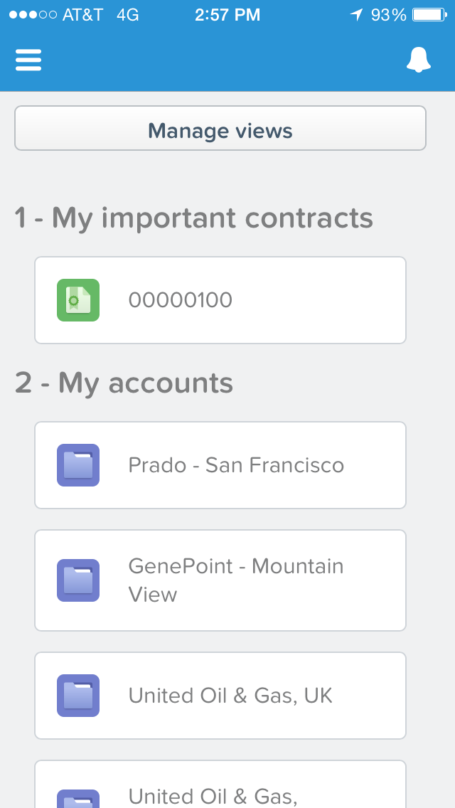 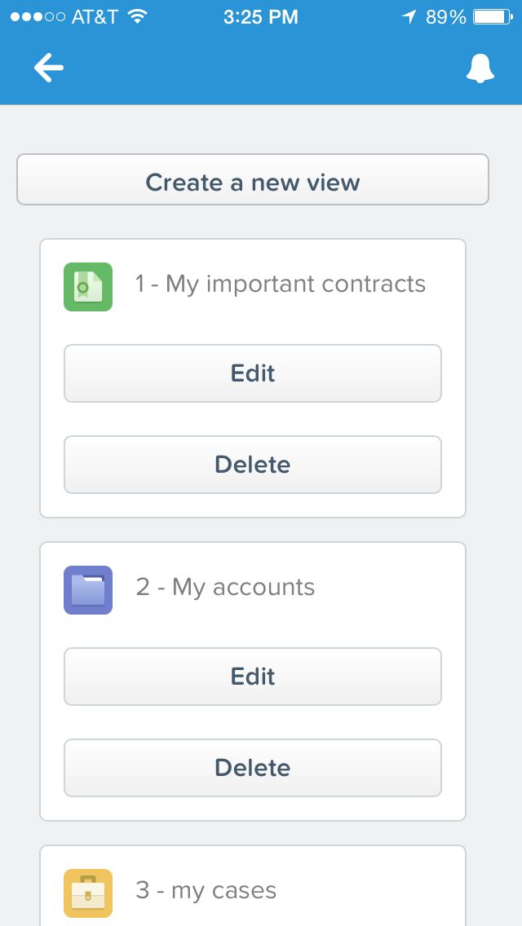

Below are screenshots to define views (name, labels, multiple filters using relationships, lookups, pick lists)

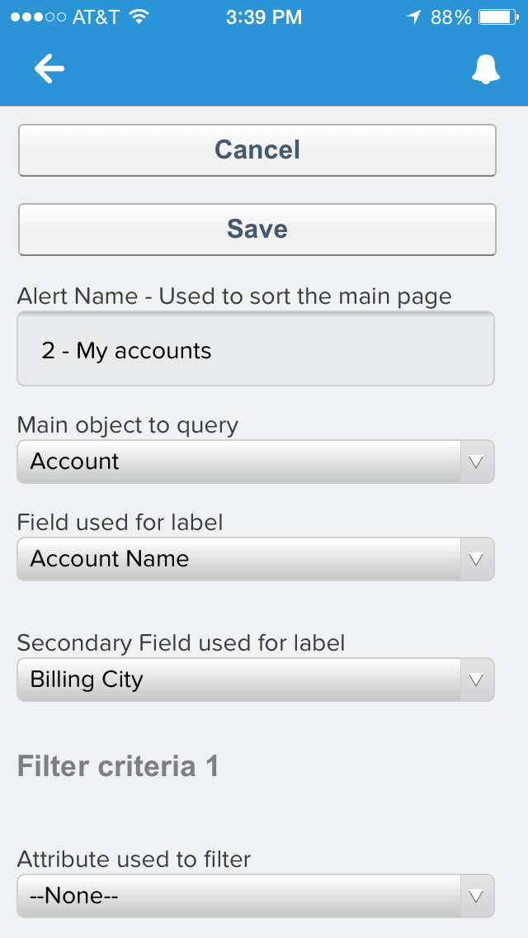 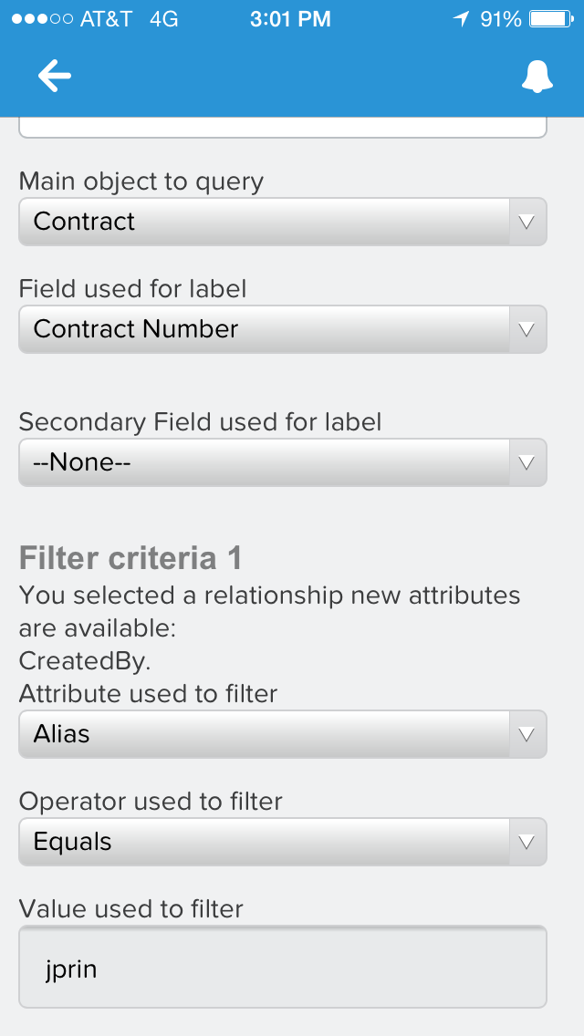 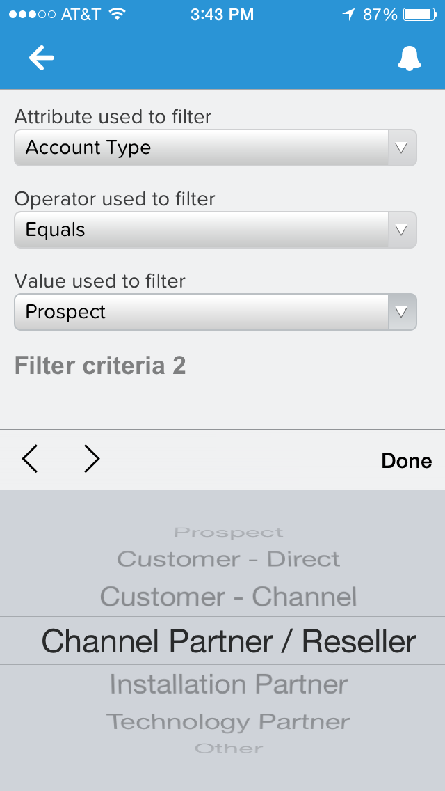

**Installation Instructions**

1. If you had previously installed this unmanaged package, you will need to uninstall any older versions. See “Uninstall Instructions” section below.
2. Install the package from the AppExchange.
   1. Grant access to all users or configure access by profile during installation
3. Add Infinite Views tab to your salesforce1 UI:
   1. Setup | Mobile Administration | Mobile Navigation
      * 1. Move Infinite Views from available to selected.
        2. [Optional] move to the top position in selected so it becomes your default.
4. [Optional] You can modify the number of criteria available by changing the getAlertIndex() method in the infiniteviews_ViewController and increasing or decreasing the array. Default is 10.
5. [Optional] You can modify the max number of objects returned in a list by modifying the line 187 in infiniteviews_ViewController and replacing 200 by the desired number. Default is 200 per views.

**Uninstall Instructions**

1. Export any view and criteria for backup if you would like to
2. Setup | Installed packages | Click on uninstall

**Known Issues & Limitations**

1. We do not support currently OR operation within one view definition across attributes. The recommended approach is to create one view for each OR operation.

2. Currently, there is no way to select multiple values from a pick list. The way to do it is to repeat the same filter condition with the values. It only works for equal and not equal. For example if you would like to include case that are NEW and CLOSED, you can create 2 status equal filters and set NEW in the first filter condition and CLOSE in the second one and so on …

3. The navigation to details only work if the object can be rendered in salesforce1

4. You can only use the application from a desktop web browser if you use the <salesforcehostname>/one/one.app url as oppose to the desktop UI.

**Change Log**

|  |  |
| --- | --- |
| Version | Changes |
| 1.0 | We will begin tracking changes after public release. |